Provisioning Report
ASAP 7.0.2 – JAMU66
&
ASAP7.0.2 – WASS1133

Month: October

November 01st, 2018
Content

1. Summary Transaction Information from JAMU66 3
2. Summary Transaction Information from WASS1133 6
3. Tickets 9
4. Platforms refusing connectivity 12
5. RFC support 14

Summary Transaction Information from JAMU66

JAMU66
Transactions |  | 282,178 | 100%
Start Date |  | 01-October-2018 00:00:00 AM
End Date |  | 31-October-2018 23:59:59 PM
Order Status | Description | Values
COMPLETED | The order was completed with successful response from the Network Element | 264,489 | 92.45%
FAILED | The order was completed with error response from the Network Element | 11,855 | 4.87%
IN_PROG | Orders in Progress | 0 | 0.00%
TIMEOUT | Orders that exceeded the execution time | 5,834 | 2.67%
TRANSL_FAIL | Orders that were not executed | 0 | 0.00%

Day | Total | Transactions  Complete | %  Complete | Transactions  Failed | %  Failed | Transactions  In_Prog | %  In_Prog | Transactions  Timeout | %  Timeout | Transactions  Trans Fail | %  Trans Fail
10/1/18 | 21506 | 20802 | 96.73% | 638 | 2.97% | 0 | 0.00% | 66 | 0.31% | 0 | 0.00%
10/2/18 | 9331 | 8919 | 95.58% | 320 | 3.43% | 0 | 0.00% | 92 | 0.99% | 0 | 0.00%
10/3/18 | 14030 | 13489 | 96.14% | 465 | 3.31% | 0 | 0.00% | 76 | 0.54% | 0 | 0.00%
10/4/18 | 7923 | 7607 | 96.01% | 267 | 3.37% | 0 | 0.00% | 49 | 0.62% | 0 | 0.00%
10/5/18 | 10997 | 10527 | 95.73% | 362 | 3.29% | 0 | 0.00% | 108 | 0.98% | 0 | 0.00%
10/6/18 | 5524 | 4968 | 89.93% | 478 | 8.65% | 0 | 0.00% | 78 | 1.41% | 0 | 0.00%
10/7/18 | 1827 | 1728 | 94.58% | 21 | 1.15% | 0 | 0.00% | 78 | 4.27% | 0 | 0.00%
10/8/18 | 10399 | 9947 | 95.65% | 370 | 3.56% | 0 | 0.00% | 82 | 0.79% | 0 | 0.00%
10/9/18 | 7336 | 6937 | 94.56% | 319 | 4.35% | 0 | 0.00% | 80 | 1.09% | 0 | 0.00%
10/10/18 | 7476 | 6347 | 84.90% | 1045 | 13.98% | 0 | 0.00% | 84 | 1.12% | 0 | 0.00%
10/11/18 | 8367 | 6994 | 83.59% | 1316 | 15.73% | 0 | 0.00% | 57 | 0.68% | 0 | 0.00%
10/12/18 | 5115 | 4749 | 92.84% | 256 | 5.00% | 0 | 0.00% | 110 | 2.15% | 0 | 0.00%
10/13/18 | 2097 | 1950 | 92.99% | 65 | 3.10% | 0 | 0.00% | 82 | 3.91% | 0 | 0.00%
10/14/18 | 666 | 557 | 83.63% | 26 | 3.90% | 0 | 0.00% | 83 | 12.46% | 0 | 0.00%
10/15/18 | 2231 | 1575 | 70.60% | 572 | 25.64% | 0 | 0.00% | 84 | 3.77% | 0 | 0.00%
10/16/18 | 12161 | 11678 | 96.03% | 396 | 3.26% | 0 | 0.00% | 87 | 0.72% | 0 | 0.00%
10/17/18 | 16866 | 16391 | 97.18% | 371 | 2.20% | 0 | 0.00% | 104 | 0.62% | 0 | 0.00%
10/18/18 | 9031 | 7873 | 87.18% | 789 | 8.74% | 0 | 0.00% | 369 | 4.09% | 0 | 0.00%
10/19/18 | 9439 | 8891 | 94.19% | 432 | 4.58% | 0 | 0.00% | 116 | 1.23% | 0 | 0.00%
10/20/18 | 4411 | 4221 | 95.69% | 89 | 2.02% | 0 | 0.00% | 101 | 2.29% | 0 | 0.00%
10/21/18 | 2037 | 1945 | 95.48% | 22 | 1.08% | 0 | 0.00% | 70 | 3.44% | 0 | 0.00%
10/22/18 | 14226 | 13798 | 96.99% | 298 | 2.09% | 0 | 0.00% | 130 | 0.91% | 0 | 0.00%
10/23/18 | 7023 | 6686 | 95.20% | 206 | 2.93% | 0 | 0.00% | 131 | 1.87% | 0 | 0.00%
10/24/18 | 9939 | 8496 | 85.48% | 298 | 3.00% | 0 | 0.00% | 1145 | 11.52% | 0 | 0.00%
10/25/18 | 16104 | 13756 | 85.42% | 645 | 4.01% | 0 | 0.00% | 1703 | 10.58% | 0 | 0.00%
10/26/18 | 13572 | 13182 | 97.13% | 283 | 2.09% | 0 | 0.00% | 107 | 0.79% | 0 | 0.00%
10/27/18 | 4673 | 4476 | 95.78% | 120 | 2.57% | 0 | 0.00% | 77 | 1.65% | 0 | 0.00%
10/28/18 | 2313 | 2156 | 93.21% | 32 | 1.38% | 0 | 0.00% | 125 | 5.40% | 0 | 0.00%
10/29/18 | 20790 | 20193 | 97.13% | 498 | 2.40% | 0 | 0.00% | 99 | 0.48% | 0 | 0.00%
10/30/18 | 15583 | 14991 | 96.20% | 464 | 2.98% | 0 | 0.00% | 128 | 0.82% | 0 | 0.00%
10/31/18 | 9185 | 8660 | 94.28% | 392 | 4.27% | 0 | 0.00% | 133 | 1.45% | 0 | 0.00%
SUMMARY  AVERAGE | 282,178 | 264,489 | 92.45% | 11,855 | 4.87% | 0 | 0.00% | 5,834 | 2.67% | 0 | 0.00%

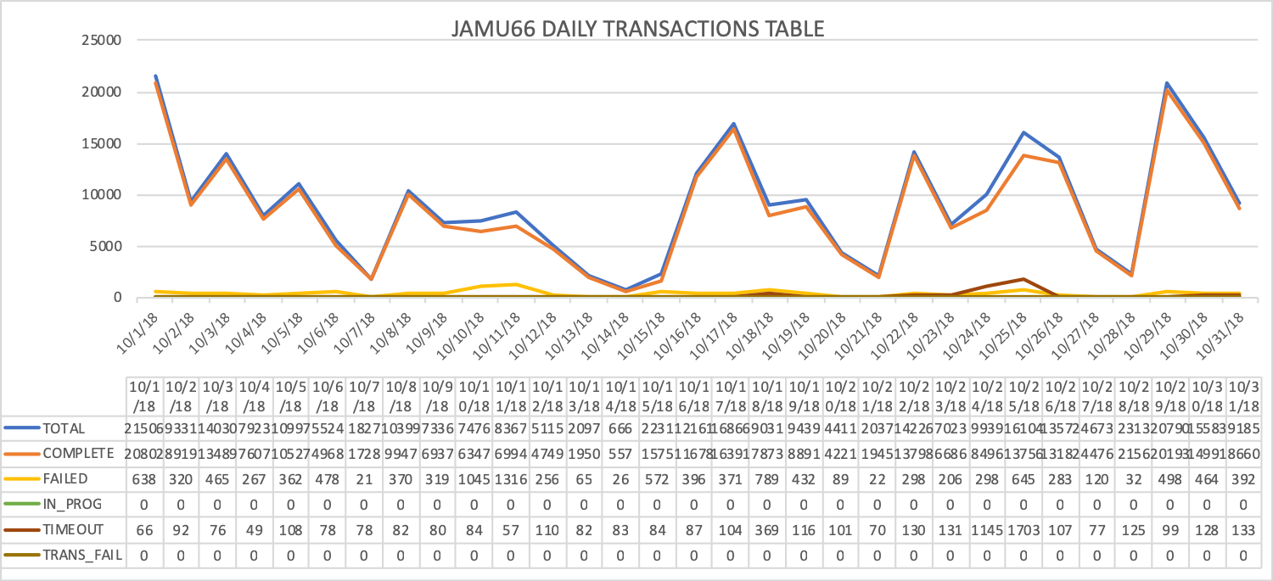

Summary Transaction Information from WASS1133

WASS1133 |  |  | %
Transactions |  | 104,428 | 100%
Start Date |  | 01-October-2018 00:00:00 AM
End Date |  | 31-October-2018 23:59:59 PM
Order Status | Description | Values
COMPLETED | The order was completed with successful response from the Network Element | 81,998 | 70.64%
FAILED | The order was completed with error response from the Network Element | 12,444 | 11.51%
IN_PROG | Orders in Progress | 0 | 0.00%
TIMEOUT | Orders that exceeded the execution time | 9,985 | 17.86%
TRANSL_FAIL | Orders that were not executed | 0 | 0.00%

Day | Total | Transactions  Complete | %  Complete | Transactions  Failed | %  Failed | Transactions  In_Prog | %  In_Prog | Transactions  Timeout | %  Timeout | Transactions  Trans Fail | %  Trans Fail
10/1/18 | 7745 | 6541 | 84.45% | 959 | 12.38% | 0 | 0.00% | 245 | 3.16% | 0 | 0.00%
10/2/18 | 3865 | 3179 | 82.25% | 410 | 10.61% | 0 | 0.00% | 276 | 7.14% | 0 | 0.00%
10/3/18 | 5114 | 4277 | 83.63% | 564 | 11.03% | 0 | 0.00% | 273 | 5.34% | 0 | 0.00%
10/4/18 | 1079 | 808 | 74.88% | 118 | 10.94% | 0 | 0.00% | 153 | 14.18% | 0 | 0.00%
10/5/18 | 4516 | 3579 | 79.25% | 591 | 13.09% | 0 | 0.00% | 346 | 7.66% | 0 | 0.00%
10/6/18 | 2133 | 1301 | 60.99% | 575 | 26.96% | 0 | 0.00% | 257 | 12.05% | 0 | 0.00%
10/7/18 | 401 | 81 | 20.20% | 63 | 15.71% | 0 | 0.00% | 257 | 64.09% | 0 | 0.00%
10/8/18 | 5774 | 4948 | 85.69% | 553 | 9.58% | 0 | 0.00% | 273 | 4.73% | 0 | 0.00%
10/9/18 | 4390 | 3625 | 82.57% | 326 | 7.43% | 0 | 0.00% | 439 | 10.00% | 0 | 0.00%
10/10/18 | 5223 | 4084 | 78.19% | 620 | 11.87% | 0 | 0.00% | 519 | 9.94% | 0 | 0.00%
10/11/18 | 3473 | 2998 | 86.32% | 304 | 8.75% | 0 | 0.00% | 171 | 4.92% | 0 | 0.00%
10/12/18 | 2715 | 2079 | 76.57% | 254 | 9.36% | 0 | 0.00% | 382 | 14.07% | 0 | 0.00%
10/13/18 | 1172 | 783 | 66.81% | 115 | 9.81% | 0 | 0.00% | 274 | 23.38% | 0 | 0.00%
10/14/18 | 525 | 203 | 38.67% | 28 | 5.33% | 0 | 0.00% | 294 | 56.00% | 0 | 0.00%
10/15/18 | 1378 | 976 | 70.83% | 100 | 7.26% | 0 | 0.00% | 302 | 21.92% | 0 | 0.00%
10/16/18 | 6518 | 5544 | 85.06% | 648 | 9.94% | 0 | 0.00% | 326 | 5.00% | 0 | 0.00%
10/17/18 | 3603 | 2762 | 76.66% | 464 | 12.88% | 0 | 0.00% | 377 | 10.46% | 0 | 0.00%
10/18/18 | 4996 | 4083 | 81.73% | 555 | 11.11% | 0 | 0.00% | 357 | 7.15% | 0 | 0.00%
10/19/18 | 2619 | 1909 | 72.89% | 343 | 13.10% | 0 | 0.00% | 367 | 14.01% | 0 | 0.00%
10/20/18 | 1271 | 853 | 67.11% | 127 | 9.99% | 0 | 0.00% | 291 | 22.90% | 0 | 0.00%
10/21/18 | 243 | 49 | 20.16% | 15 | 6.17% | 0 | 0.00% | 179 | 73.66% | 0 | 0.00%
10/22/18 | 3721 | 2891 | 77.69% | 430 | 11.56% | 0 | 0.00% | 400 | 10.75% | 0 | 0.00%
10/23/18 | 3205 | 2381 | 74.29% | 408 | 12.73% | 0 | 0.00% | 416 | 12.98% | 0 | 0.00%
10/24/18 | 3497 | 2352 | 67.26% | 831 | 23.76% | 0 | 0.00% | 314 | 8.98% | 0 | 0.00%
10/25/18 | 4894 | 3521 | 71.95% | 1068 | 21.82% | 0 | 0.00% | 305 | 6.23% | 0 | 0.00%
10/26/18 | 2482 | 1927 | 77.64% | 231 | 9.31% | 0 | 0.00% | 324 | 13.05% | 0 | 0.00%
10/27/18 | 1333 | 997 | 74.79% | 116 | 8.70% | 0 | 0.00% | 220 | 16.50% | 0 | 0.00%
10/28/18 | 627 | 192 | 30.62% | 22 | 3.51% | 0 | 0.00% | 413 | 65.87% | 0 | 0.00%
10/29/18 | 7228 | 6326 | 87.52% | 595 | 8.23% | 0 | 0.00% | 307 | 4.25% | 0 | 0.00%
10/30/18 | 5380 | 4381 | 81.43% | 577 | 10.72% | 0 | 0.00% | 422 | 7.84% | 0 | 0.00%
10/31/18 | 3308 | 2368 | 71.58% | 434 | 13.12% | 0 | 0.00% | 506 | 15.30% | 0 | 0.00%
SUMMARY  AVERAGE | 104,428 | 81,998 | 70.64% | 12,444 | 11.51% | 0 | 0.00% | 9,985 | 17.86% | 0 | 0.00%

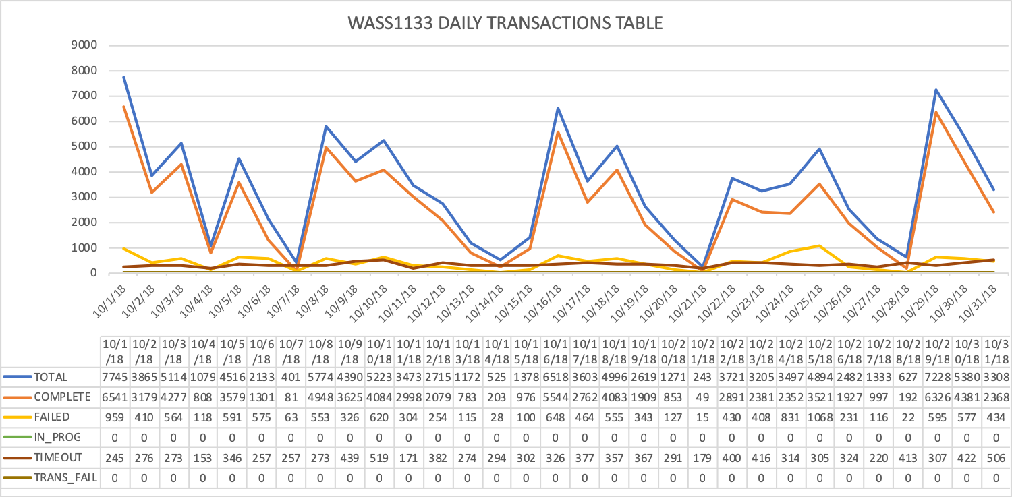

Tickets
October Statistics
Tickets | 48
Severity
LOW | 42
MEDIUM | 1
HIGH | 5
Origin
ispemailsupport | 1
Joy | 3
Keith Aimable | 1
Kenyatta | 1
Madhusudan | 3
Mounika | 6
Prakash | 7
Praneetha | 15
Satya | 4
Shivanchyut | 1
Terry Calderon | 1
Terry Hunt | 1
Connection Refused | 4

Accumulative
Tickets | 376
Severity
LOW | 264
MEDIUM | 61
HIGH | 51
Origin
Abhijit | 2
asap.support | 16
Barbara | 2
Chinnasani | 8
Connection Refused | 47
FLOW IT AUTOMATED PROVISIONING | 1
Harish, Prakash | 2
Herme | 1
IGATE LIBERATE TIER 2 SUPPORT | 1
ispemailsupport | 1
JaganMohan | 1
Jason | 1
Joy | 21
Juan Pablo | 4
Keith Aimable | 1
Kenyatta | 3
Kishore | 14
Kishore, Shalana | 1
León | 1
Madhusudan | 10
Marcia | 1
Mark | 2
Mora Case | 2
Mounika | 24
Neilsa | 105
Neilsa, Chinnasani | 1
Neilsa, Kishore | 1
Nola | 2
Pradeep | 1
Prakash | 26
Praneetha | 38
Rhonda | 2
Rosaline | 1
Samantha | 7
Satya | 4
Shalana | 3
Shivanchyut | 3
Suresh | 8
Terry | 3
Terry Hunt | 1
Uday | 2
Wendy | 1

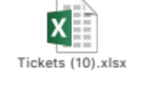

Platforms refusing connectivity

CONNECTION REFUSE E-MAIL TITLE | DATE | STATUS
ASAP monitor; connection refused SLU_UVF | 24/1/18 | CLOSED
ASAP monitor; connection refused EST_GSAT & EST_GSAT1 | 25/1/18 | OPEN
ASAP monitor; connection refused SLU_UVF | 30/1/18 | CLOSED
ASAP monitor; connection refused SLU_UVF | 2/2/18 | CLOSED
ASAP monitor; connection refused SLU_UVF | 5/2/18 | CLOSED
ASAP monitor; connection refused SLU_UVF | 6/2/18 | CLOSED
ASAP monitor; connection refused SLU_CEN | 5/2/18 | CLOSED
ASAP monitor; connection refused SLU_UVF | 9/2/18 | CLOSED
ASAP monitor; connection refused JAM_CALIX | 13/2/18 | OPEN
ASAP monitor; connection refused SLU_UVF | 16/2/18 | CLOSED
ASAP-WASS133-ASAP There is no connection to Database -No Listener | 18/2/18 | CLOSED
ASAP JAMU66 shutdown | 22/2/18 | CLOSED
ASAP monitor; connection refused SLU_UVF | 22/2/18 | CLOSED
ASAP monitor; connection refused CAY_GNBND with WASS1133 | 22/2/18 | OPEN
ASAP monitor; connection refused SLU_UVF | 22/2/18 | CLOSED
ASAP monitor; connection refused SLU_UVF | 28/2/18 | CLOSED
WASS1133-ASAP provisioning asappro1 user fails to login | 28/2/18 | CLOSED
ASAP monitor; connection refused SLU_CEN | 5/3/18 | CLOSED
JAM_MOBY connection failure | 9/3/18 | CLOSED
ASAP-FLOW-monitor, Unable to connect to remote host: Connection refused to SLU_UVF | 13/3/18 | CLOSED
ASAP monitor; connection refused SLU_UVF | 14/3/18 | CLOSED
ASAP monitor; connection refused SLU_UVF | 28/3/18 | CLOSED
ASAP monitor; connection refused SLU_UVF | 2/4/18 | CLOSED
ASAP monitor; connection refused SLU_UVF | 3/4/18 | CLOSED
ASAP monitor; connection refused JAM_EAST | 3/4/18 | CLOSED
ASAP monitor; connection refused SLU_UVF | 5/4/18 | CLOSED
ASAP monitor; connection refused SLU_UVF | 9/4/18 | CLOSED
ASAP connection refused SONUS | 11/4/18 | CLOSED
ASAP connection refused SONUS | 16/4/18 | CLOSED
ASAP monitor; connection refused SLU_UVF | 16/4/18 | CLOSED
ASAP monitor; connection refused SLU_UVF | 26/4/18 | CLOSED
ASAP monitor; connection refused SLU_CEN | 26/4/18 | CLOSED
ASAP monitor; connection refused SLU_UVF | 30/4/18 | OPEN
ASAP monitor; connection refused SLU_UVF | 2/5/18 | CLOSED
LIME-ASAP-jamu66-Connection Fail to SONUS platform | 28/5/18 | CLOSED
ASAP monitor; connection refused SLU_UVF | 11/06/18 | CLOSED
ASAP monitor; connection refused SLU_UVF | 11/06/18 | CLOSED
ASAP monitor; connection refused SLU_UVF and SLU_CEN | 19/06/18 | CLOSED
ASAP monitor; connection refused SLU_UVF and SLU_CEN | 21/06/18 | CLOSED
ASAP-Route Activation traffic to wass1133 | 24/06/18 | CLOSED
ASAP monitor; connection refused SLU_UVF | 03/07/18 | CLOSED
ASAP monitor; connection refused SLU_UVF | 04/07/18 | CLOSED
ASAP monitor; connection refused SLU_UVF | 23/07/18 | CLOSED
ASAP - connection problems. | 02/10/18 | CLOSED
[E] RE: ASAP issues in Cayman | 18/10/18 | CLOSED
ASAP monitor; connection refused SLU_UVF | 29/10/18 | CLOSED
ASAP monitor; connection refused SLU_UVF | 31/10/18 | CLOSED

RFC support

CONCEPT | DATE
RFC 4080434 - Barbados HLR CP Upgrade from R12B to R15A | 25/01/2018
|RFC6786| SCHEDULED RFC NOTIFICATION Cleandata Routine Maintenance on JAMU66 | 22/02/2018
RFC6955-Reroute provisioning on Barbados HLR to Jamaica HLR - MW3 | 7/03/2018
|RFC7430| SCHEDULED RFC NOTIFICATION Routine Maintenance: ASAP Cleandata on JAMU66 server | 11/04/2018
|RFC8041| SCHEDULED RFC NOTIFICATION ASAP Cleandata Maintenance Activity - JAMU66 | 24/05/2018

